Security(C)

Cloud computing is an external form of data storage and software delivery, which can make it seem less secure than local data hosting.

Using cloud computing, anyone can access if they have authority. Crowd Research Partners (2018) reported that cloud computing had higher risk of security breaches than traditional on-premises environments. It had 49% of respondents think cloud computing have security breaches. But only 17% of respondents think traditional on-premises environments have security breaches.

Running Costs(P)

Cloud computing is more cost effective than traditional IT infrastructure due to methods of payment for the data storage services.

With cloud-base services, you only pay for what is used – similarly to how you pay for utilities such as electricity. Meinardi(2018) point out when starting to use cloud based services, user may need to pay more money. When after four years, the cost will be steady decline due to learning how to apply cost optimization best practices.

Traditional IT infrastructure requires purchase equipment and additional server space upfront to adapt to business growth. User can manage their own data in their data center. If data center have any problems, user need to repair their data center. It may spend a lot of money to slove it.

**References**

1. Crowd Research Partners. (2018). Cliud Security Report. Retrieved from <https://pages.cloudpassage.com/rs/857-FXQ-213/images/2018-Cloud-Security-Report%20%281%29.pdf>

2. Medinardi. (2018). Is Public Cloud Cheaper Than Running Your Own Data Center. Retrieved from <https://blogs.gartner.com/marco-meinardi/2018/11/30/public-cloud-cheaper-than-running-your-data-center/>

**PhotoLink**

(for Security)

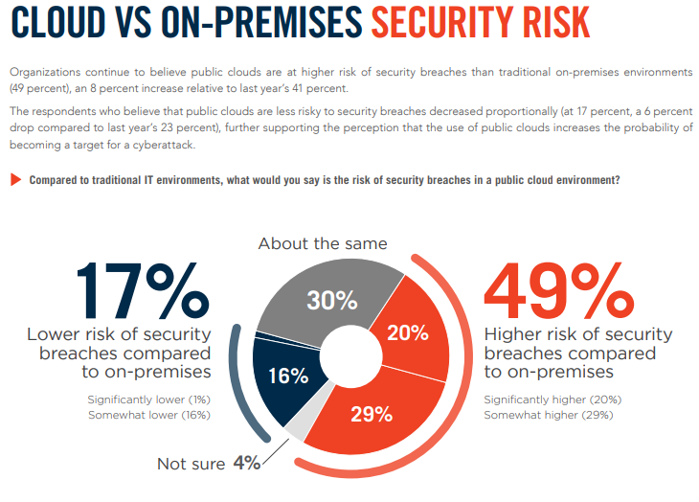

<https://pages.cloudpassage.com/rs/857-FXQ-213/images/2018-Cloud-Security-Report%20%281%29.pdf>

(P.11)

(for running costs)

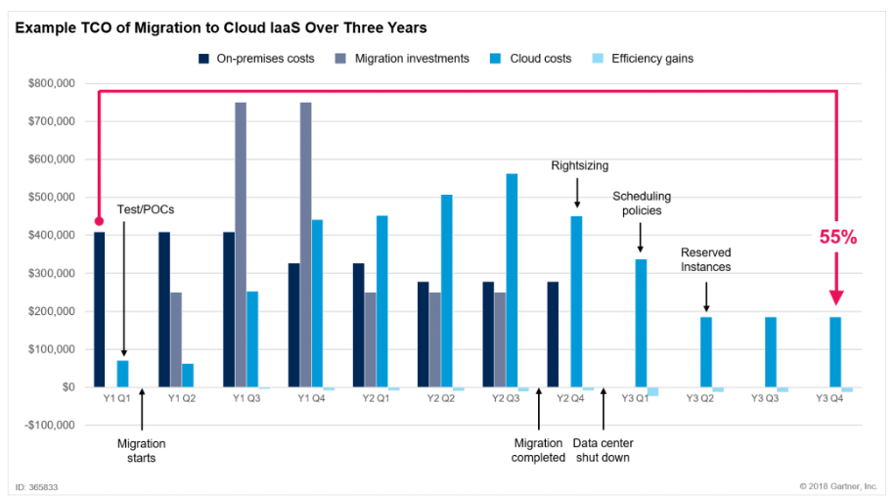

<https://blogs.gartner.com/marco-meinardi/files/2018/11/365833_0010.png>

(This photo had explain the cost using in cloud computing after four years)

**HTML code**

(for Security)

<a href="<https://pages.cloudpassage.com/rs/857-FXQ-213/images/2018-Cloud-Security-Report%20%281%29.pdf>"></a>

(for running costs)

<a href="<https://blogs.gartner.com/marco-meinardi/2018/11/30/public-cloud-cheaper-than-running-your-data-center/>

"></a>